

Future Consumer 2027:

Emotions

WGSN ensures the world’s leading brands create the exact products that tomorrow’s consumers will buy

**“** FUTURE CONSUMER 2027

Our emotions shape who we are, connect us with others and define what it means to be human.

Since the pandemic and the polycrisis that followed, emotion became the central driver of all consumer behaviour. How

we shop, what we buy and the brands that we choose have become inextricably linked with the way that we feel.

For brands, understanding these emotional drivers is fundamentally important. Your success will be determined by how your future consumers react to your brand’s narrative, products and the experiences that you create.

**”**

In our new flagship forecast, Future Consumer 2027: Emotions, we offer a roadmap to these key emotions and explain how you can create the right products for your consumers by tapping into their thoughts, feelings and behaviours.

Nik Dinning

Vice President of Marketing, WGSN



EMOTIONS [WGSN](https://www.wgsn.com/en)

FUTURE CONSUMER 2027

#### Introduction

Know how consumers will behave before they even know it themselves

This forecast provides a roadmap to future-proof your business, enabling you to understand exactly how consumers will be feeling in two years’ time and, importantly, how they will *want* to feel.

Emotions offer a new framework for understanding consumers and supercharging product innovation, business growth and customer engagement. They are a powerful tool that can be harnessed to shape how customers react to your brand’s narrative, products and experiences, ultimately influencing their purchasing decisions and building brand love.

WGSN’s flagship forecast, Future Consumer 2027: Emotions, identifies six key emotions that will shape consumer behaviour in 2027. The following pages provide a preview of three of those emotions, which will be crucial for understanding and engaging with your future consumers:



* **Strategic Joy:** to combat negativity and reimagine the world as a more inspiring, inclusive and affirming place, joy will be essential
* **Witherwill:** defined as “the longing to be free from responsibility,” it will shape 2027 as people continue to be overwhelmed amid a polycrisis
* **Suspicious Optimism:** as people grow apprehensive about the role of technology and AI, they will be tempering optimism with suspicion

These consumer emotions should be used as an overarching narrative for developing business strategies and hyper- targeted product lines across fashion, beauty, food and drink, interiors, sports and outdoor and consumer tech.

To discover all six consumer emotions set to define 2027,

[request a WGSN demo](https://www.wgsn.com/en/future-consumer-2027?utm_campaign=future-consumer-2027&utm_medium=referral&utm_source=whitepaper&utm_content=demo-report&utm_term=noterm)**.**

EMOTIONS [WGSN](https://www.wgsn.com/en)

The WGSN

Methodology

Our job is to make you and your brand successful. The rigour of our proprietary STEPIC™ methodology reinforces the accuracy of our forecasts, currently standing at **93%**, helping you de-risk decision-making and – crucially – keep you in profit.

We contextualise global research, design directions and quantitative and qualitative data to deliver strategic

###### Observe

STEPIC

1

Society TechnoLogy Environment PoLitics Industry Creativity

###### Synthesise

Aesthetic Connection

2

AnaLytics and Data ModeLLing

###### Forecast

5

FUTURE CONSUMER 2027

###### Focus

4

Trading

forecasts and analytics, which are fundamental to product development, planning and trading.

Our signature STEPIC™ methodology is the lens through which we observe and synthesise seemingly disparate factors that converge to become a trend. This methodology uses data from a range of sources, including shows, social media, retail, searches and sentiment analysis, to predict trends and help clients make informed decisions.

This data, combined with the forecast intelligence of our 250+ experts worldwide, makes WGSN the most accurate forecasting tool in the world.

WGSN Proprietary Data WGSN Experts

CriticaL Debate

3

Consumer Insight LifestyLes Product Design

Continuous Monitoring

###### Re-evaluate

EMOTIONS [WGSN](https://www.wgsn.com/en)

FUTURE CONSUMER 2027

# Strategic Joy

##### This emotional state couples joy with purpose, and it will be a reaction to feelings that have dominated the last few years – prolonged stress, boredom and dysregulation (an inability to control emotional responses as a result of feeling too many of them at once).



EMOTIONS [WGSN](https://www.wgsn.com/en)

## Strategic Joy

FUTURE CONSUMER 2027

Building on our previous forecasts of Awe for 2024, Imagination for 2025 and Glimmers for 2026, **Strategic Joy** will emerge in 2027 as the natural next step, as consumers and businesses embrace play in pursuit of self-discovery, connection, inspiration and inclusivity.

Cultivating joy is not only good for personal health – it’s also good for business health: in a survey of more than 2,000 Australians and New Zealanders, [**almost six in 10**](https://mainframe.theresearchagency.com/hubfs/Play%20Report-FA.pdf)said playful or humorous brands made them feel better about a company or organisation, and in the US, unhappy workers cost firms [**$1.9tn**](https://www.bloomberg.com/news/articles/2024-01-23/unhappy-at-work-quit-quitting-costs-us-1-9-trillion-in-productivity)in lost productivity in 2023.

In 2027, the power of play will inspire people to embrace positive habits and mindsets.

Expect to see a bigger focus on collective effervescence (the shared positive feeling felt at crowd events) and healthier or more mindful habits and experiences such as train travel, which has been [**linked**](https://x.com/jiayingzhao/status/1645146784292012032)to greater happiness.

Play will also help consumers move from a mindset of ‘what is’ to ‘what if?’ and experiment with new boundaries,

reimagining the world not only through AI but also KI (kid intelligence, which cherishes the virtues of childlike wonder). Consumers will also embrace pleasure activism, and they will turn inward to prioritise their wellbeing and serenity. Brands have a golden opportunity to support consumers in these quests.



EMOTIONS [WGSN](https://www.wgsn.com/en)

## Strategic Joy

FUTURE CONSUMER 2027

#### in action

Three key consumer emotions will shape the state of **Strategic Joy**: feeling **dysregulated**, **stressed** and **bored**. As global challenges mount, these feelings will demand evolved mindsets and imaginative solutions, moving consumers toward three aspirational emotions: feeling **included** in a broader cultural narrative, feeling **serene** amid chaos, and becoming deeply **inspired** by the world.

These emotional goals will set the tone for future creative endeavours that are as strategic as they are joyful.

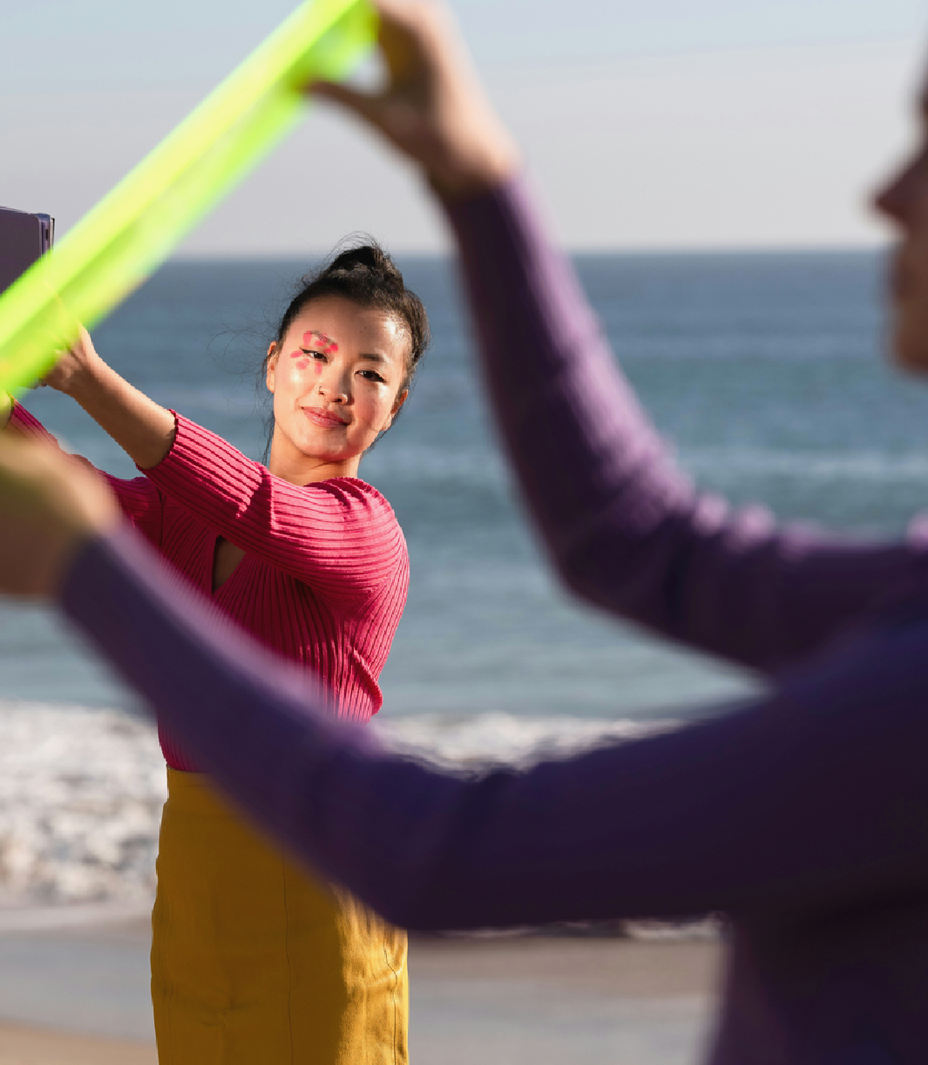

EMOTIONS [WGSN](https://www.wgsn.com/en)

# Witherwill

FUTURE CONSUMER 2027

##### Witherwill means “the longing to be free from responsibility” and it will become a key coping mechanism as people grapple with pressures on multiple levels in 2027.



EMOTIONS [WGSN](https://www.wgsn.com/en)



FUTURE CONSUMER 2027

Witherwill

As previously forecast, 2026 will be defined by the great exhaustion, with workplace and digital stressors creating a pervasive sense of burnout and overwhelm. **Witherwill** – a word coined by John Koenig, author of The Dictionary of Obscure Sorrows – will be a reaction against this, as

people push back to explore a slower existence with lower stakes, fewer to-do lists, more meaningful connections and less loneliness.

While exhaustion hinders our ability to handle future challenges, Witherwill will be a key tactic to overcome them, helping people navigate fatigue and find healing, both individually and collectively. This can already be seen in emerging escapes designed to help people free themselves, such as Both Sides, a retreat for men to escape modern-day stressors and reconnect with their sense of purpose.

Witherwill is also playing out in the digital arena, with more people opting out of tech and embracing

‘ping minimalism’ – the act of removing unnecessary notifications from devices. This quest for less noise and more digital disconnection is still seen by some as a radical act of defiance, but it will become increasingly normalised by 2027, emerging as a demonstration of

self-care that will lead consumers to be more curious and loving. Some TikTokers [**have already started**](https://www.tiktok.com/discover/vienna-billy-joel?lang=en)leaning into this sentiment via Billy Joel’s 1977 song Vienna, which has become a viral Gen Z anthem thanks to its pertinent lyrics about self-acceptance and slowing down.

In 2027, the pursuit of Witherwill will align with a focus on dishabituation (breaking away from unhelpful habits) to help people achieve a return on their energy.

EMOTIONS [WGSN](https://www.wgsn.com/en)

### Witherwill

FUTURE CONSUMER 2027

#### In action

Three core emotional drivers will shape the state of **Witherwill**: a sense of being

**overwhelmed** with responsibility; of feeling **lonely**; and a growing **empathy** for others. In 2027, people will find themselves caught in a delicate balance between personal needs and collective obligations, and this tension will give rise to two primary responses:

a retreat into isolation and a desire for connection. Propelling us forward will be **aspirations** of becoming **carefree**, feeling **curious**, and embracing **love** – both for ourselves and for those around us.



EMOTIONS [WGSN](https://www.wgsn.com/en)

FUTURE CONSUMER 2027



# Suspicious Optimism

##### Amid seismic technological change, Suspicious Optimism will be a default emotional state for many in 2027

EMOTIONS [WGSN](https://www.wgsn.com/en)

FUTURE CONSUMER 2027



## Suspicious Optimism

WGSN has been tracking optimism for years, including **Tragic Optimism** for 2024 (the search for meaning amid complex challenges) and **Rational Optimism** for 2026 (the idea that it makes more sense to be optimistic than pessimistic in a world that’s constantly changing). In 2027 many people will be tempering their optimism for the future with scepticism and suspicion,

particularly regarding the role of technology, as we grapple with both the **positive** and **negative** impacts of AI, as well as continuing threats of divisions and distortions online.

In an age of information and disinformation, consumers are armed with an arsenal

of inputs that can inspire awe, fear or disillusionment, and this can be exacerbated in a world where people consume media that aligns with their class, age, location or ideological preferences, resulting in a world of myriad self-reinforced realities.

As we head into 2027, content creators will assume a new importance and power in shaping these realities, whether it be to

curb or fuel suspicions about the future. For brands, it will be essential to help consumers make sense of a world in flux so they can find their way to wisdom, balance and trust.

EMOTIONS [WGSN](https://www.wgsn.com/en)

## Suspicious Optimism

FUTURE CONSUMER 2027

#### in action

**The state of Suspicious Optimism** will be driven by three key emotions: **awe** at the potential of new innovations; **fear** of unintended consequences; and **disillusionment** from past disappointments and expectations. As 2027 approaches, consumers will navigate complex relationships with technology, oscillating between fascination and apprehension. These drivers will propel us toward **aspirational states** of **wisdom**, **balance** and **trust** in our technological interactions.



EMOTIONS [WGSN](https://www.wgsn.com/en)

### Thought Starters

FUTURE CONSUMER 2027



How can you integrate play and joy into your products and internal processes to improve the health and happiness of your customers and your business?

1

As people face pressures on multiple fronts, how can you lighten their load and help them enjoy a less pressured life with fewer responsibilities?

2

Technology is transforming our world at warp speed. How can you build trust and inspire optimism in its potential to create a better future for all?

3

EMOTIONS [WGSN](https://www.wgsn.com/en)

FUTURE CONSUMER 2027

##### About WGSN

Trend forecasting solutions for people ahead of their time

Our foresight helps businesses understand the changes they need to act on now so they can make the best products and services for tomorrow.

If you need to know what will fill consumers’ wardrobes, bathroom shelves, kitchens or even their hands in the future, WGSN’s proven combination of consumer insight, data and industry expertise will guide you.

For more than a quarter of a century, we have predicted the big macro shifts in consumer lifestyle, values and needs to ensure our clients achieve future product and commercial success.



[WGSN](https://www.wgsn.com/en)

[Contact us](https://www.wgsn.com/en/future-consumer-2027?utm_campaign=future-consumer-2027&utm_medium=referral&utm_source=whitepaper&utm_content=demo-report&utm_term=noterm) to see how we can future-proof your business today.